 Maintaining Direct Deposit Information

Begin by navigating to the Direct Deposit page by clicking on the “Direct Deposit” tile

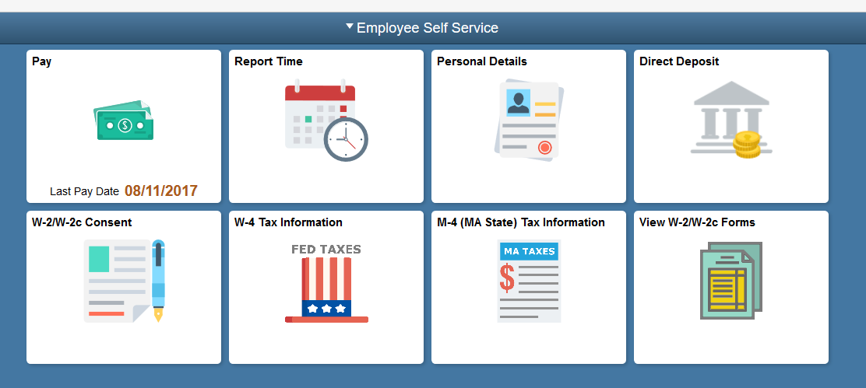
Use the Direct Deposit page to view current direct deposit information or to add a new account.
If you already have a direct deposit account, you will need to verify the existing account information before you can make any updates.
For this example, you are going to add a savings account.

Click the Add Account button.
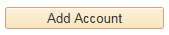
Use the Add Direct Deposit page to add or change direct deposit information.

To reduce security risk, please enter one existing Direct Deposit account number, then hit Enter or Tab out of the field to continue to make your change.

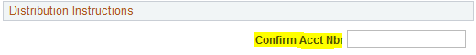
You must provide the routing and account information from your bank so that your payroll is deposited into the correct account.

You can get this information from your personal checks. If you're not sure how to read this information, click the View check example link.
Use the Check Example page to view where the routing and account numbers appear on your check. The highlighted sections show which part of the numbers are the Routing Number and which are the Account Number.
Click the OK button.
Enter the desired information into the Routing Number field.

Enter a valid value e.g. "011000138".
Enter the desired information into the Account Number field.

Enter a valid value e.g. "123456789".
Use the Account Type field to select the type of account you are adding.

Click the Account Type list.
Click the Savings list item.
Use the Deposit Type field to specify whether you would like to deposit a flat amount, a percentage, or the balance of your pay.

Click the Deposit Type list.
You can specify a flat amount or a percent. If multiple accounts are used, you can specify to use the balance of the paycheck amount for one of the accounts. For example, you might deposit 50% into a checking account and the balance into a savings account.
For this example, you are going to deposit 10% into a savings account.

Click the Percent list item.
Enter the desired information into the Amount or Percent field.

Enter a valid value e.g. "10.00".
Use the Deposit Order field when you are depositing to more than one account. For example, if you're depositing 50% in a checking account and the remaining net pay in a savings account, the checking account, which is the first account that money is being deposited into, would have a deposit order of 1 and the savings account a deposit order of 2, and so on for additional accounts.

Note: Keep in mind that the account to which your remaining pay, or balance, is deposited into is assigned the Deposit Order of 999.
Enter the desired information into the Deposit Order field.

Enter a valid value e.g. "2".
Click the Save button.
Notice the text on the page indicating that this may not be reflected with your next paycheck.

Click the OK button.
The account information is now displayed. If you want to view the details of this account in read-only format, you can click the Account Type link.
Click the Savings link.
Use the Direct Deposit Detail page to view your direct deposit details. This page is displayed in read-only format. Notice that you cannot modify the fields on this page.
Click the Return to Direct Deposit link.
Use the Edit button if you need to make modifications to an account.

Click the Edit button.
To reduce security risk, please enter one existing Direct Deposit account number, then hit Enter or Tab out of the field to continue to make your change.

Use the Change Direct Deposit page to modify your direct deposit information. You can modify all fields on this page.
Click the Return to Direct Deposit link.
Your savings account information has been added and saved which now displays on the Direct Deposit page.
The Savings account displays the Deposit Order number 2 and the Checking account, the remainder balance, displays the Deposit Order number 999.
Congratulations! You have successfully updated your direct deposit information.
End of Procedure.

